Creating a Portfolio On Weebly
A How-to Guide

By Brenly Drake

Table of Contents

Introduction 2

Each screen explained

1. Elements 3
2. Design 6
3. Pages 7
4. Editors 9
5. Settings 10

Building a website step-by-step
Naming and creating 12
Modifying header text 14
Editing an image 15
Tips on designing a homepage 17
Adding another page 17
Creating a resume page 18
Inserting a document 21
Adding a blog 22
About Me page 23

Troubleshooting tips 25
Final words 26

Why should I get a portfolio?

As you near graduation, you might be considering how your degree translates to the real world. What is the path to a “grown up job”? What on earth makes one candidate for a job more worthwhile than the others?

What can help you get a job is a solid portfolio of work. A portfolio is a showcase of your work. This is your chance to impress an employer with samples of what you will be creating for them. This is especially useful for jobs that require you to synthesize material such as writing, audio, or graphics.

Having a website to use your portfolio is a great way for an employer to access your samples with little to no hassle.

Before starting on this manual, you’ll need the following things:

1. A computer that is online.

2. A Weebly account. This is free.

3. Knowledge of document editing. A tiny amount of knowledge of how to click and drag and how to modify text. Some of this will be explained in the manual anyway.

4. Before starting on this manual you need to have materials for a portfolio.
What things did you create during your school career?
Would someone give you money to make more?

Navigating Weebly

Weebly is an excellent website builder, with plenty of options.

At the top are the title tabs. Clicking on each of these will send you to a different screen that each have their own purpose. We’ll discuss each one.

The title tabs are as follows:
Elements, Design, Pages, Editors, Settings

We’ll be going through the title tabs one by one, explaining each screen.

1. Elements screen
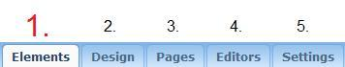

The elements screen will be shown below, and then each item will be explained.

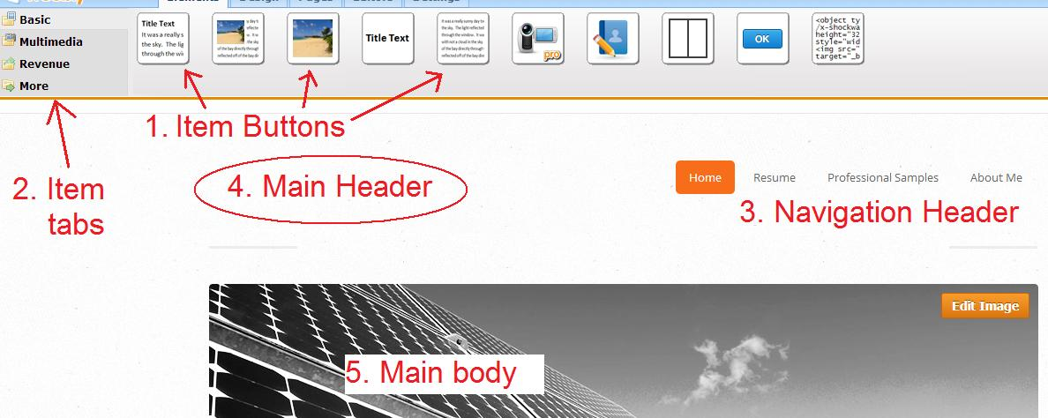

1. The item buttons are where items can be dragged from this area onto the main header/body. Placing these items provide content for your home page.

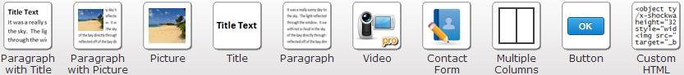

2. Item tabs
The item tabs have a series of tabs that change which item buttons are currently displayed.
Basic
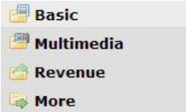

Multimedia
Revenue
More

The Basic tab shows the standard items that can be used to construct a website such as paragraphs and images.

The Multimedia tab shows the flashier items to place: audio files, videos, and Youtube windows.

The Revenue button doesn’t apply to what we’re doing. It includes options for advertising and sales.

The More button includes more options that we won’t be using. RSS feeds and custom html as advanced options.

(Elements Screen cont.)

3. Navigation header
The navigation header serves two purposes. This will display how the navigation bar will look on your finished website. It also helps you select which page is currently being modified.

4. Main header
This area displays how the header will look on the finished page. Objects can be dragged onto this.

5. Main body
The main body is how the body will look on the finished page. Objects can be dragged onto this

2. Design screen
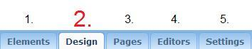

When the title tab “Design” is chosen, the item buttons and tabs switch to design options.

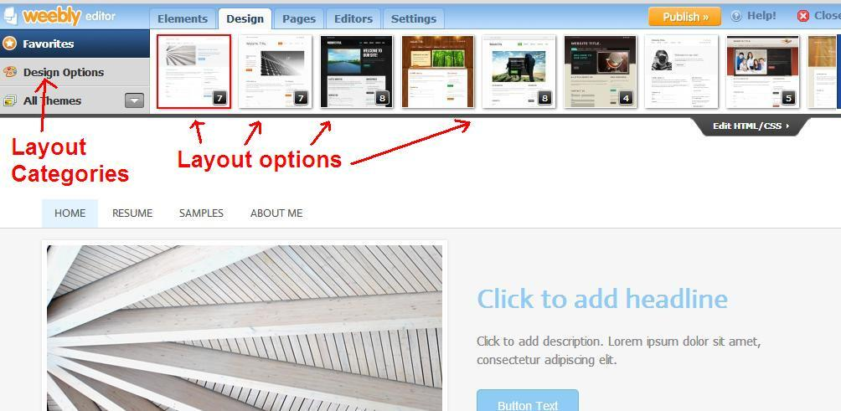

The item bar now contains options to change the overall layout of your website. Changing the layout effects each page on the site.

Layout categories help you navigate between the many layout options available to you.

Layout options are where you can pick and choose the options to effect the website you are building. There is no right or wrong lay out, a matter of personal preference.

The next tab is the Pages screen.

3. Pages Screen
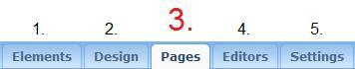

Choosing the Pages title tab allows the website’s pages to be viewed in an overall list fashion and modified as needed.

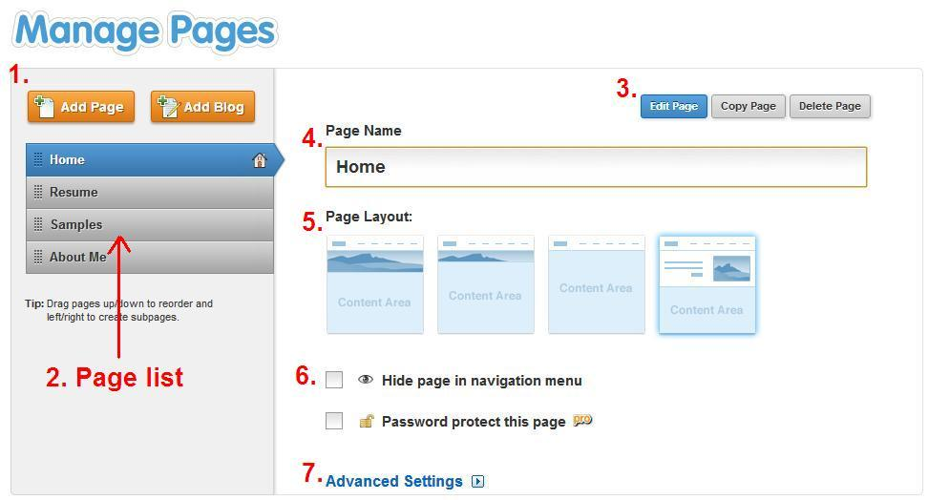

1. The add page button adds a new page. The new page will be in the page list.

2. The page list is an overview of the pages in your site. They are listed in the order that they appear in the finished site’s top menu. The individual items in the list can be dragged as needed to change their order.

3. The three buttons that appear here only apply to the page selected.
The “Edit Page” button switches to the Elements screen.

The “Copy Page” button duplicates the page. Useful if you’re making a few pages that are similar to have differences laid out later.

The “Delete Page” button does just that; delete the page.

4. The page name box contains the name of the page. A new page name can be typed in the box as needed. The new name will be displayed in the page list as well as in the published product.

5. Page layout selects a template for the page. This can be useful for a jump start on formatting a newly created page.

6. This area contains privacy options. A page can be hidden or password protected.

7. Clicking on Advanced settings will bring up the advanced options. These mostly apply to how the page interacts with search engines.

The next tab is the Editors screen.

4. Editors screen
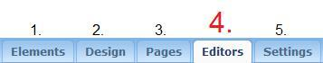

On this fourth of five screens, we’ll be taking a brief look at the Editors screen shown below.

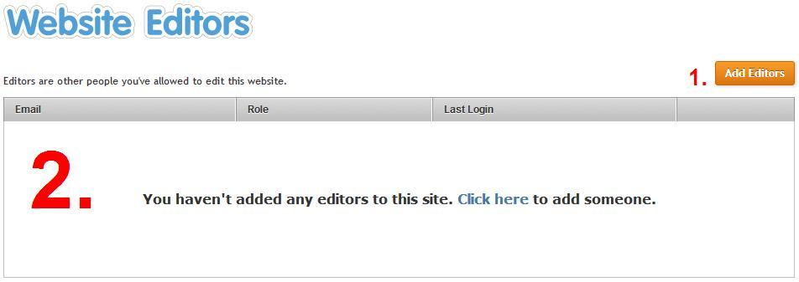

The editors screen is where you can add accounts for others to modify the website. An email invitation will be sent to the person.

This is useful if multiple people contribute content. Different levels of permissions can be utilized.

1. The add editors button is how this process is started

2. This area lists the current editors of the site.

The next tab is the Settings screen.

5. Settings screen
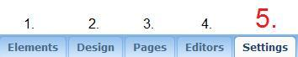

The settings page contains items to change elements of the site. The url, the password related to private portions of the site, and options for Facebook sharing.

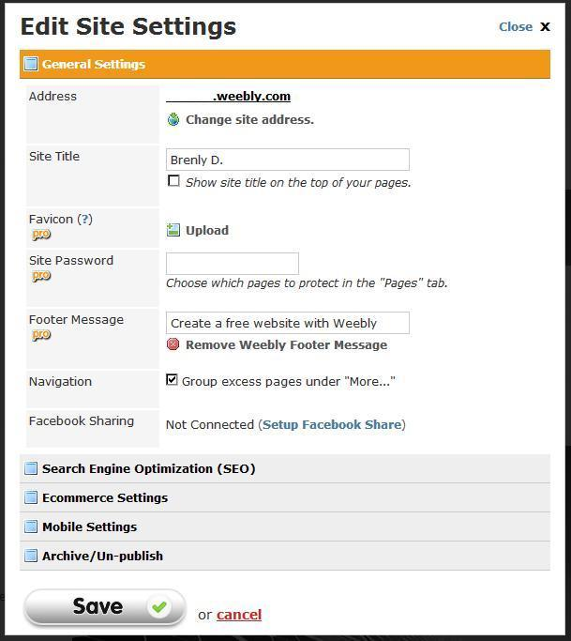

(Settings page cont.)

The settings page will be explained item-for-item. We’ll discuss seven items.

1. The URL of your site will need to be kept simple, something that can either be easily memorized or at least read off a business card. This is what people will be typing into their web browser to visit your site, so make it count.

2. A site title isn’t as important as it sounds. Don’t over think it. Keep it simple: Name, portfolio type, and that’s it.

3. A fav icon is what appears in some people’s web browsers at the top corner. It’s a tiny mostly meaningless function. If you’re attempting to create a website that’s more memorable as a name brand, this would be useful. For a simple portfolio it won’t be needed.

4. A site password is what you’d use for protected parts of your page. If you choose to use it, follow basic password guidelines that can be found on the web. For what we’re doing, we won’t use it.

5. A footer message isn’t important either. A free Weebly account has a default mandatory message. Leave it be.

6. Navigation contains a check box. This will abbreviate your Navigation Header. It’s useful if you have a big site. Again, we’re making a simple portfolio, so this won’t be an issue.

7. Facebook sharing can be useful. If the job you’re striving for is social media related, then you might want to consider linking a Facebook page to show off some of your social media skills.

Building a website step-by-step

Knowing what each screen is capable of is a good start. However, learning by doing is just as important. So, let’s get started on building a site!

If you’re starting from the account management page, you’ll need to click Add Site to create the page. This will start the dialogue. Otherwise, if you’re creating a new Weebly account the dialogue will be started for you.

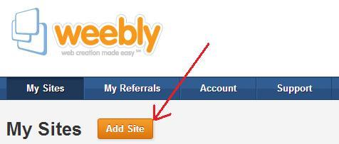

Naming and creating the site

You’ll need to give the site a name and choose its type. For the sake of this manual we’ll be using the type ‘Portfolio.’

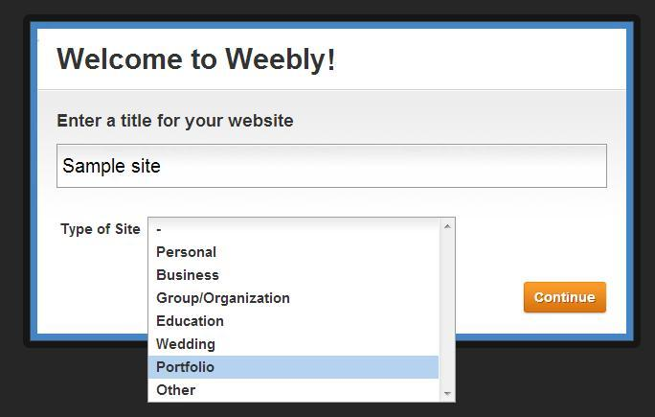

Next, you’ll need to choose the domain. This is the URL of your website, the address that people might need to type in. It helps to make it easy to remember, or at least easy to read off a business card. Long strings of numbers won’t help you here.

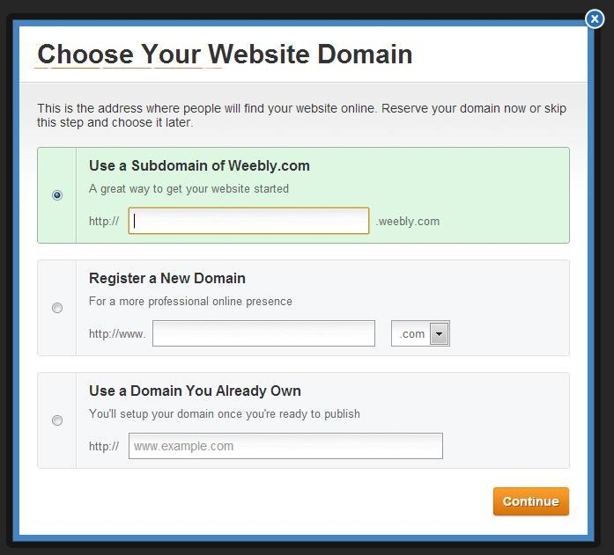

After those things have been arranged, you should be on the Elements screen of your new site that has yet to be built.

To get things jump started, we’ll select a premade layout.

Go to the Design title tab and in the Items bar select a good design. The trick is to pick something professional and somewhat minimal. You don’t want your future boss to strain reading your wonderful samples beneath a loud header. You don’t want your polished samples competing with the backgrounds jarring out of the margins.

I’ve chosen a lovely minimal set of solar panels. You can personalize the premade images later if you’d like.
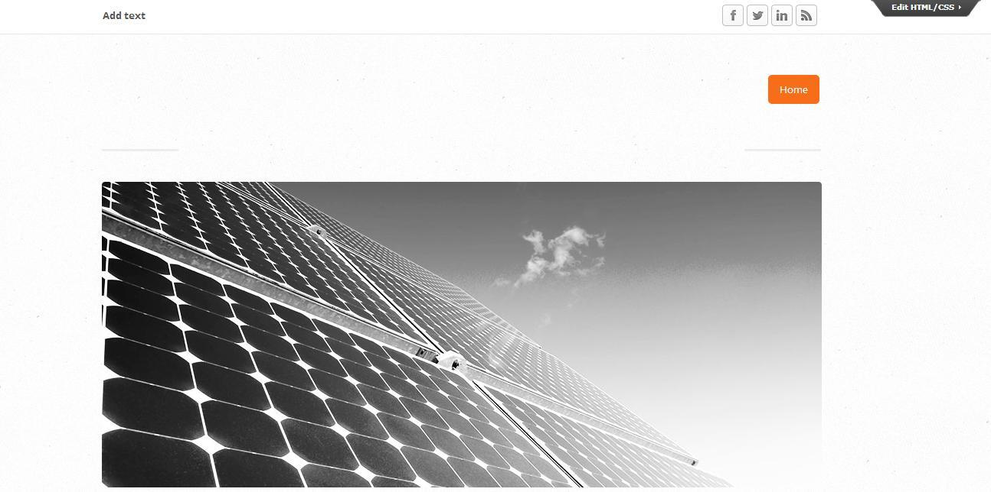

Modifying header text

To modify text, you’ll simply need to click in the text area to be changed.
A gold box will appear around it indicating your selection.
Then type the new text.

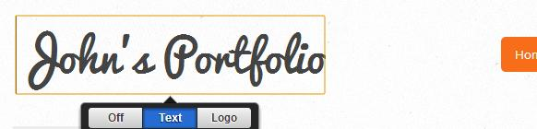

1. To change the font you’ll need to click on the Design title tab.
2. Then use the Design Options item tab.
3. Then, to the right of that will be a new list. Click Site Title.
Note in #3 that there are other types of text that can be modified.

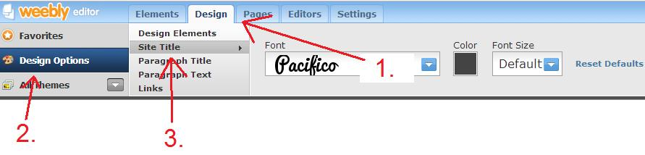
In this example, I’ve changed the header font to something more professional looking. Pacifico looks too much like the third grade. It simply won’t make the cut.

Click the blue arrow next to the font name and choose a font from the drop down menu.
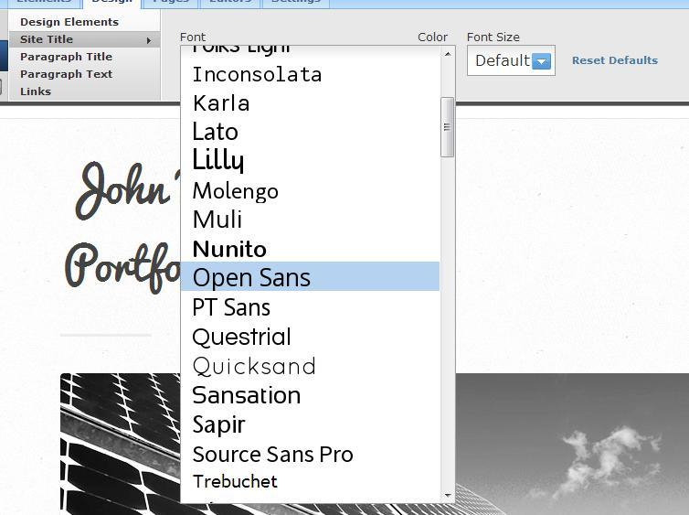
Almost there...

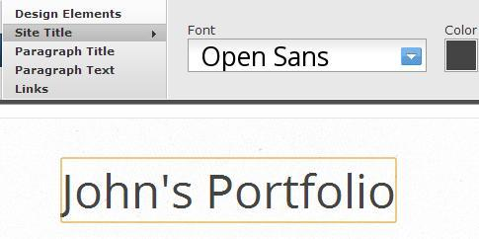
Much better.

Changing the title image
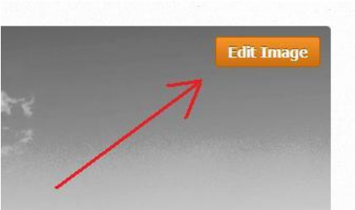

My solar panels will actually work out nicely. But if you wish to change the title image, simply click on it.
A button will appear called “Edit Image”

When you go into the edit image mode, the menus at the top will change over to controls that will allow you to accomplish this.

Editing an image

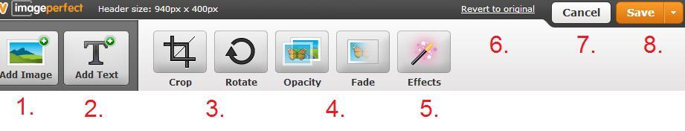

Each button has a different function, as explained below:

1. The Add Image button adds an image. You can upload an image from your personal computer or specify an address on the web.

2. The Add Text button adds text to each image
3. Crop changes the sizing, cutting off edges of the image as you may need. Rotate simply rotates the image clockwise.

4. Opacity and fade are a bit specialized, but can be useful. They blend the background to the website behind it.

5. The special Effects are somewhat limited. There options for color changes and special fancy edges to the image. However for the purpose of this site you might be better off without.

6.
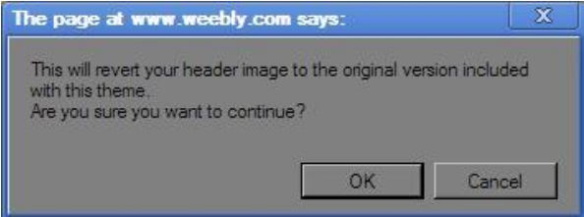
Revert to original changes whatever image, wenther saved or unsaved, back to the template default. A dialogue box will ask you if you’re sure.

7. Cancel lets you exit the menu with no hassle.

8. The Save button completes the process and saves the changes. Clicking the side arrow will bring down a menu with the options:
a. Save as default header. This will allow you to forward the changes to all of the other pages.
b. Save only to this page performs the same function as the save button.
c. Only to selected pages... brings up another dialogue that asks you to specify which pages the changes are saved to.

Now that we’ve got the header fixed up, there are a few things to think about for design.

Designing a home page

This page that you create will be the first thing your employer sees.
What do you want them to think about you?
What will they think you can do?
Would they give you a job?

And on a different level of importance:
What colors will they associate with you?
What do they think you do for a hobby?
Would they want to chat with you over the water cooler?

Your homepage should contain just enough material to entice someone to keep browsing.

Once you’ve designed a homepage you should be on your way to creating more pages.

Adding another page

To add another page, head to the Pages screen through the title tabs.



You will want to go ahead and add a new page, titled “Resume”

1. Click “Add page” this will add a page to the website, viewable through the left sidebar.

2. Change the page name to “Resume” by typing it into the box. You may have to backspace the default page name.

3. Choose the most basic layout. Your resume page should have the least amount of design features out of the rest of your site.
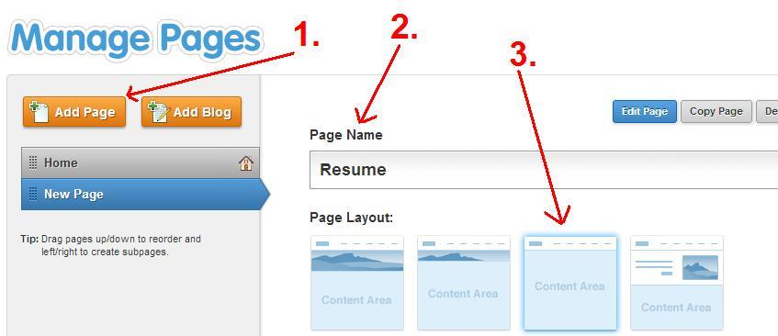

Creating a resume page

It is a good idea to minimize the bells and whistles on the resume page. Your best bet is to have it closely resemble the basic white paper that would be faxed or mailed to an employer.

The best way to do this is to write a resume on a separate word document and transfer.

We’ll run through steps showing how to drop a paragraph box into the page.

1. Use the Pages screen to create a page titled “Resume”.

2. Head to the Elements tab to begin modifying it.

3. Be sure you are editing the Resume page by clicking on the “Resume” title in the navigation header.

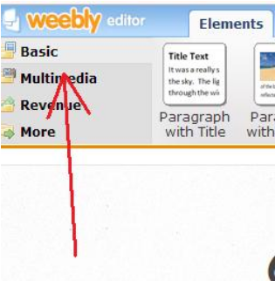
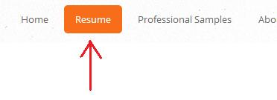
4. In the item tabs make sure that Basic is chosen.

5. Click and drag the Paragraph item button onto the page to begin an empty area of text to be modified.

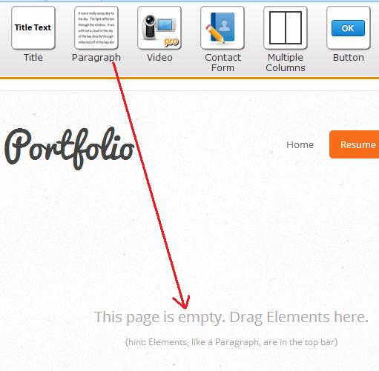

Then…

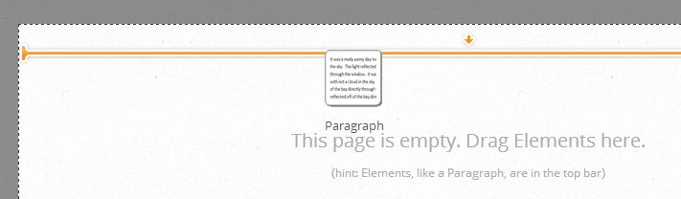
Note the orange line. These help you identify boundaries of objects that have been placed.
The boundaries are designed to help you place a new object.

Modifying a text box

Hover the mouse over the newly placed text box. It is located where the text ‘Click here to edit’ appears.

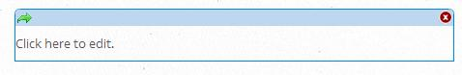
A red ‘X’ at the top right corner of the box allows you to quickly remove it.

Click the box to edit the text.

Note that basic word processing is available towards the top in a blue box.

The buttons in the text box are standard fare, except the plus and minus buttons change the font size of the text.

The easiest thing to do is copy/paste a plain text version of your resume into the paragraph box and then format it using the word processing options.

You’ll need to make a separate paragraph box for the standard center aligned header and the rest of the right aligned text.
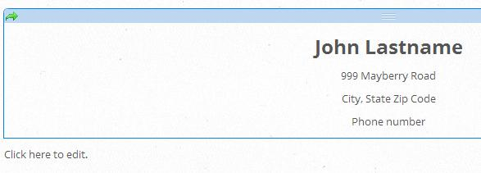

To modify the font of the paragraph boxes you’ll need to go to four things:

1. Click on the Design Tab

2. Click the Design Options item tab

3. Click the Paragraph Text tab on the right of Design Options

4. Change the font by clicking the drop down menu

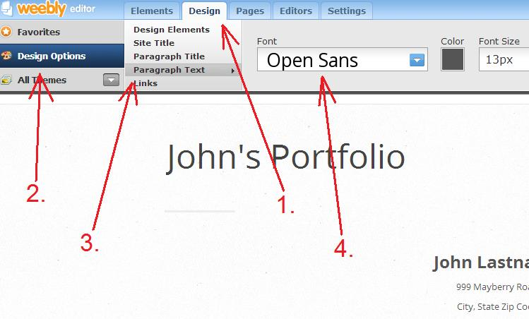

You can refer to the Internet if you need help on the content of your resume.
There are plenty of free resources available.

Inserting a document

A good way to show off professional writing is to insert a document.

To add samples of professional writing, go to the Pages title tab to add a page titled “Professional samples”

For the purpose of this manual, I’ll show you how to insert a special document window but then show you a more effective way and cheap way to show off your writing.

Make sure that you are in the Elements window.
Make sure that Professional Samples page selected in the Navigation header.

1. You’ll need to ensure that Multimedia is selected in the item tabs

2. Then you’ll need to click and drag Embedded Document to your page.

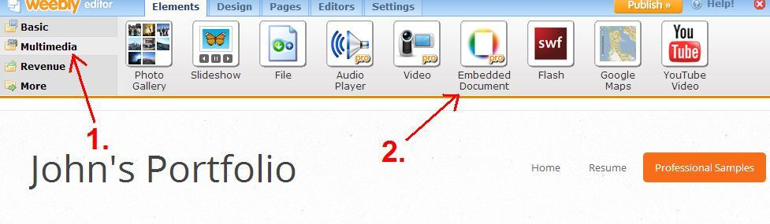
The Embedded Document requires a paid account to Weebly. This might be useful to some, but a portfolio is just a parking spot. There’s no need to pay for parking when there’s plenty of room on the Internet.

The other cheaper option is to add a blog. This is actually very easy.

Adding a blog

Head back to the Pages screen and delete your old Professional Samples page.

1. Ensure that your old Professional Samples page is selected. Try not to delete the wrong page!

2. Click the delete button to eliminate it. You won’t need it.

3. Click the Add blog button. Title it “Professional Samples”

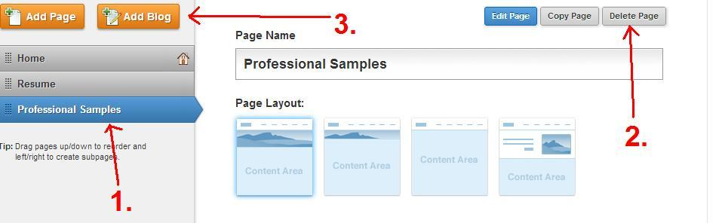
Then you can modify your Blog as needed.

You can add a new post. Make a new post for each separate professional sample

Three or four separate samples should be enough. You may want to eventually replace old ones with newer better ones as you progress.

You won’t need to use the Comments button, but this is where you can approve individual comments as needed. Instead, disable comments using Blog settings.


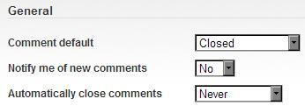
Above: Closed, No, Never, Don’t bother.

Introduction/About Me Page

Now, add an introduction page. You can title it either Introduction or About Me depending on your personal preference.

I’ve chosen the same blank slate as the Resume page for ease of building.

1. If you look at the Navigation Header you’ll see what a nice site you’ve been building so far. Make sure that About Me is the page that is selected here.

2. Click and drag the Paragraph with Picture item button to the body of the page.

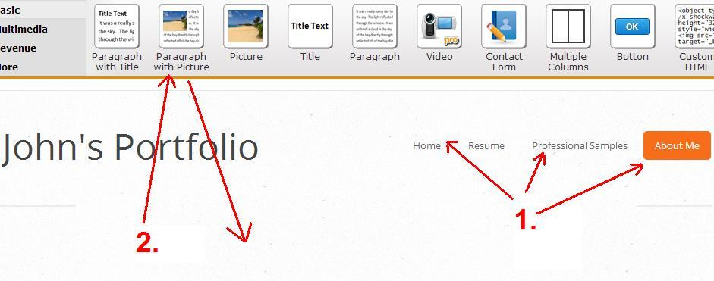

The main body will now contain a template of a paragraph with image.
You can click on the image to bring up a dialogue to upload or choose an image.
You can click on the text “Click here to edit” to insert your paragraph.
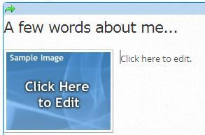
Choose an image from your computer or online.

You’ll need to upload a picture of yourself. A nice one.
Don’t upload a picture you took at a bar.
Perhaps a picture of you at your current job.
Perhaps a picture of you doing some recreational activity.
You’ll want the picture to be tasteful, but you’ll want a picture of you.

I’ve chosen to upload a picture of a cat for a sample. I like cats.

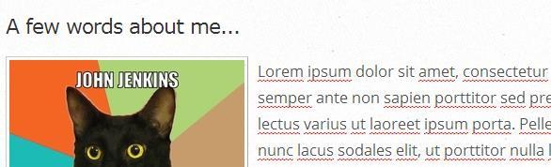

Fill in a paragraph concerning you. Write information that isn’t on your resume.
Consider including a couple of sentences that show your personality.

If you wish to add more images or paragraphs, you can click and drag the corresponding button.

At this point, you should have a portfolio website built. You’ve included a set of pages that are useful to inform employers to who you are. Next we’ll discuss troubleshooting, and then some final words.

Troubleshooting tips

I’ll share with you some points worth knowing as you modify the website.

1. Some of the modifications apply to the whole site.
If you change a header font, the header fonts across the entire site will be changed. This helps create a uniform appearance throughout the site.
Keeping this in mind, you’ll need to keep an eye on your Editors Screen to make sure that you’re headed in the right direction as you build your site.

2. Delete, delete, delete.
Most anything that is drag-and-drop on Weebly will have a red ‘X’ at the top right corner of the screen. If you slip, or don’t want something anymore, just remove it.

3. Deleting things is an irreversible action.
Weebly is a good site editor, but does not contain an Undo button.
Consider this as you go along. Sometimes it’s easier to rename or retype something instead of deleting the entire item.

4. When using the Pages screen, save your settings.
Weebly is excellent in streamlining most options. However, be sure to click the ‘Save settings’ button after making your changes in the Pages screen. A simple click of this button may save you lost work in the future.

5. Don’t forget to Publish.
When your page has been built, it won’t be on the internet just yet.
Be sure to hit the Publish button when you’re done. It is located at the top right corner next to the Close and Help! Buttons.


Some final words

Now that you’ve done a layout of your site, you should be well on your way to finishing a portfolio. A good portfolio will provide information for future employers to consider how useful you’ll be.

You might want to consider rereading the introduction of this manual.
Consider the content of your page.
What things can you do?
What can you give your employer?
Think of this portfolio as a job interview.

Your college career so far has set you with skills. You have done assignments through your college years that have exhibited those growing skills. If none of your assignments are good to put on a portfolio you may want to consider taking a few days to build portfolio materials.

Find good essay prompts. Find an inspiring topic, and blog about it on another site. Pick the best posts for your professional samples. If you’re a graphic designer, you may want to make a set of useful graphics with all the skills you’ve learned.

Building a portfolio might not be easy, but a good effort will produce a good exhibit of who you are. These efforts may just lead to a decent job. Good luck.

